ANZSIN Bulletin
April 2016

Welcome to the first newsletter for 2016.

Mission of ANZSIN (Australia and New Zealand Special Interest Group in Interventional Nephrology). The promotion and safe application of interventional procedures in order to improve the care and outcome of patients with kidney disease.

Aims: Provide leadership and promote education and research in interventional nephrology through our objectives, which include: development of and coordinating training programmes, ongoing education, developing clinical outcome monitoring programmes and accreditation standards. We will promote Nephrology and Interventional nephrology in particular as a career choice.

9th ANZSIN annual meeting (Perth, WA. 21-23 September 2016)
On behalf of the organising executive committee I am delighted to invite and encourage you to attend the next interventional nephrology meeting – planned for Wednesday afternoon 21 to Friday 23 September 2016. As with previous years, our meeting follows our parent society (ANZSN) annual scientific meeting.

Dr Akira Miyata, Director of Nephrology, Kumamoto, Japan is our overseas guest speaker. Dr Miyata has extensive skills in trauma and interventional vascular treatment. He brings a wealth of knowledge and experience to our meeting. We look forward to his presentations sharing his wide and varied practical knowledge.

The ANZSIN conference will be held at Fraser Suites, with both the conference meeting facilities and accommodation at the one-site venue - juxtaposition to the Swan River. Fraser Suites are a new development in a relaxing environment situated only 3km away from the Perth Convention Centre (site of the main ANZSN meeting); within the free-transit public transport zone of Perth permitting the freedom to enjoy the local city facilities in conjunction with your conference visit.

For more information on this year’s meeting – visit:
http://www.anzsinmeeting.org/ehome/index.php?eventid=154982&

This year’s 52nd ANZSN annual scientific meeting is a combined meeting with the APSN’s 15th APCN; and coupled with this exciting joint meeting will be our 9th annual meeting. We do hope you will be able to attend this progressive and stimulating week of nephrology to both extend your knowledge in nephrology and then join us for a varied and interesting interventional nephrology meeting with our hands-on workshop.

12th ASDIN annual scientific meeting (Phoenix, Arizona. 19-21 February 2016)

Dr Steve May and I attended this American meeting held in Phoenix in February this year. Dr May will present at our 9th ANZSIN interventional meeting some of the high-lights from the 12th ASDIN meeting.
ANZSIN modelled our meeting on the ASDIN format. If you have been to or heard about an ASDIN meeting before, I am sure this will encourage you to attend the 9th ANZSIN meeting in Perth in September.

The ASDIN meeting in Phoenix covered much in the complications of haemodialysis access and their management; and peritoneal dialysis access and similarly complication management. Topics of unique management and discussion included: developments in haemodialysis stent grafts and their patency rates; innovations in access patency therapies; management of repeated complications of access; and training within the interventional specialty. Guest speaker Dr Maurzio Gallieni of Milan, Italy gave a fascinating review of development of vascular access since the onset of haemodialysis.

The meeting discussion sessions – as in previous years – permit the various interventional techniques, their pros and cons to be aired within the group of varied experience and knowledge. The opportunity to meet and talk to these experienced interventionists and select the ‘best of the best’ techniques to incorporate into one’s own individual practice is immense; and makes the attendance at interventional meetings so valuable. The hands on session we will have at our ANZSIN meeting on Friday 21 September will hopefully be of potentially similar benefit to you.

For more information of the ASDIN society, their activities and future activities programme, visit: http://www.asdin.org/

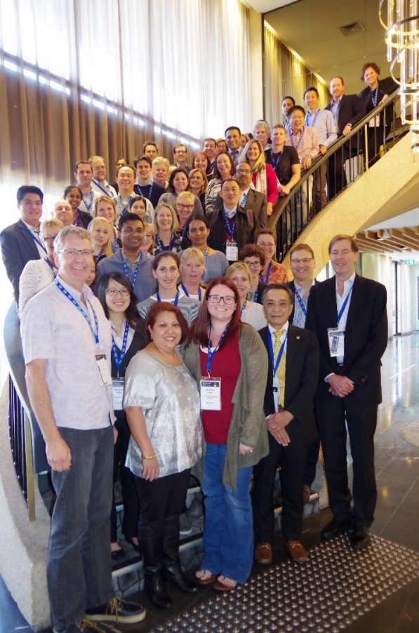
“Team photo” of the 2015 meeting attendees

David Voss ED*** FRACP
Chair of ANZSIN Special Interest Group

